EXPERIMENT NO. 5
Task-Level Parallelism using OpenMP Sections and Tasks
Objective
To understand and implement task-level parallelism using OpenMP sections and task constructs, and to analyze their suitability for independent, irregular, and dynamically generated tasks.
OpenMP is commonly used to parallelize loops, but some applications are better represented as a collection of independent operations or dynamically generated work. Task-level parallelism allows different tasks to execute concurrently. In OpenMP, sections are suitable for a small, fixed number of independent tasks, while task constructs are suitable for dynamically generated or irregular tasks.
Examples from the experiment include AI/ML preprocessing, computer vision, scientific computing, graph processing, robotics, multimedia pipelines, recursive algorithms, and parallel compilation.
Concept | Simple meaning | Best suited for
parallel for | Splits loop iterations among threads. | Large number of similar iterations.
sections | Assigns different fixed blocks of work to different threads. | Small, fixed independent operations.
task | Creates units of work that OpenMP schedules dynamically. | Irregular, recursive or dynamically generated work.
single | Ensures one thread creates the tasks. | Task creation inside a parallel region.
taskwait | Waits for child tasks created by the current task. | Dependencies before continuing.

3. Task 1 – Independent Tasks using OpenMP Sections
Problem: Calculate the sum, maximum, minimum and average of an array. First execute the four operations sequentially and then execute them concurrently using OpenMP sections. Both versions must produce identical results.

Sequential C++ Code
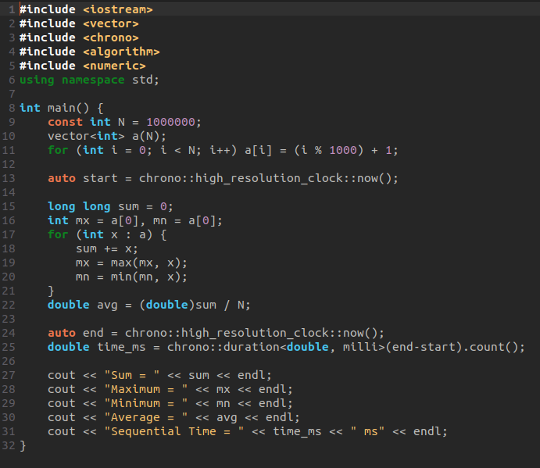

OpenMP Sections Code
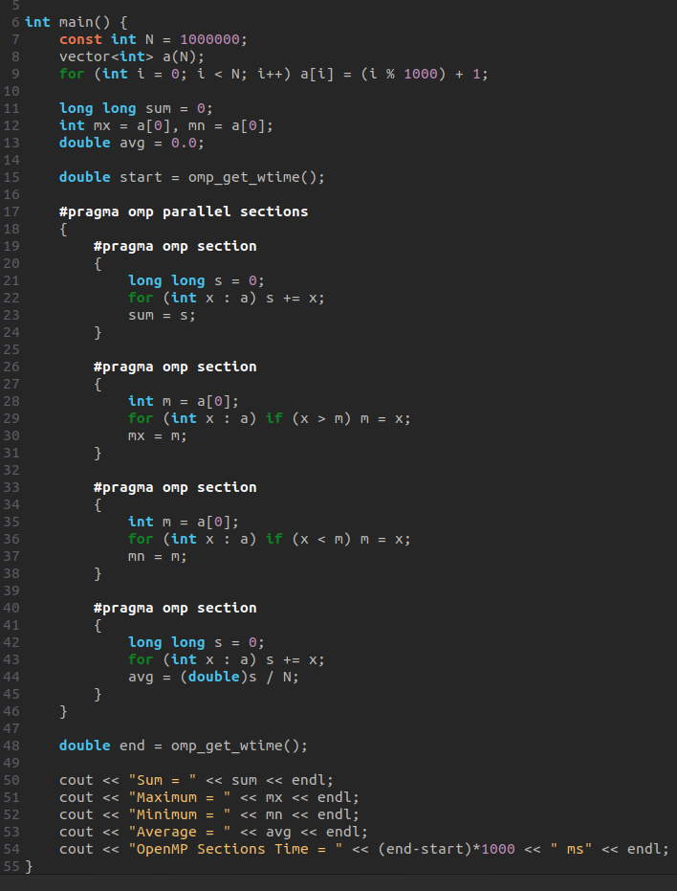

Sample Output
Sum = 500500000
Maximum = 1000
Minimum = 1
Average = 500.5
Sequential Time = 8.20 ms
OpenMP Sections Time = 3.10 ms

Speedup
Speedup = Sequential Time / Parallel Time. Using the sample values: Speedup = 8.20 / 3.10 ≈ 2.65.

Task 1 Discussion Answers
Why can the four operations execute concurrently? They read the same input array but calculate independent results, so one operation does not need the result of another.
Why is sections suitable? There are exactly four fixed and independent operations. Each operation can be placed in its own section.
What if sections are fewer than threads? Only as many threads as there are sections can perform section work at the same time; extra threads may remain idle.
Will more threads always improve performance? No. There are only four sections, so using many threads cannot create more than four useful section workers. Thread creation and scheduling overhead can also reduce performance.

4. Task 2 – Sections vs Parallel For
The experiment asks for Sum, Maximum, Minimum and Count of even numbers using both parallel for and parallel sections.

Parallel For Code
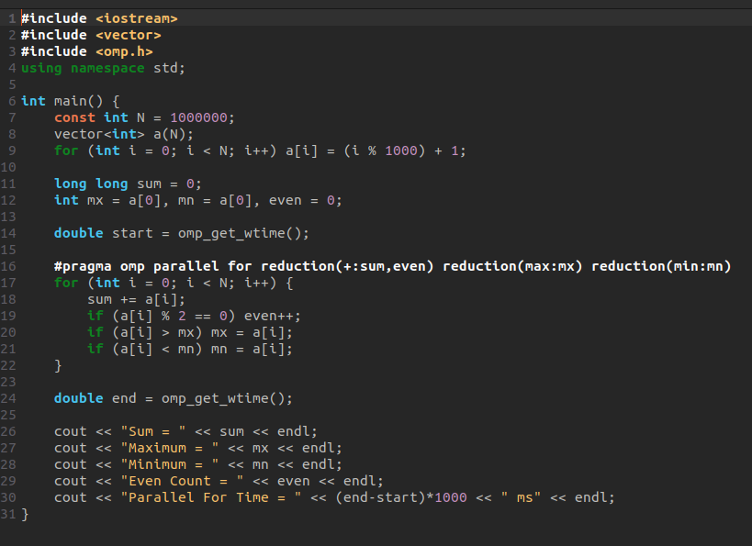
#

Parallel Sections Code
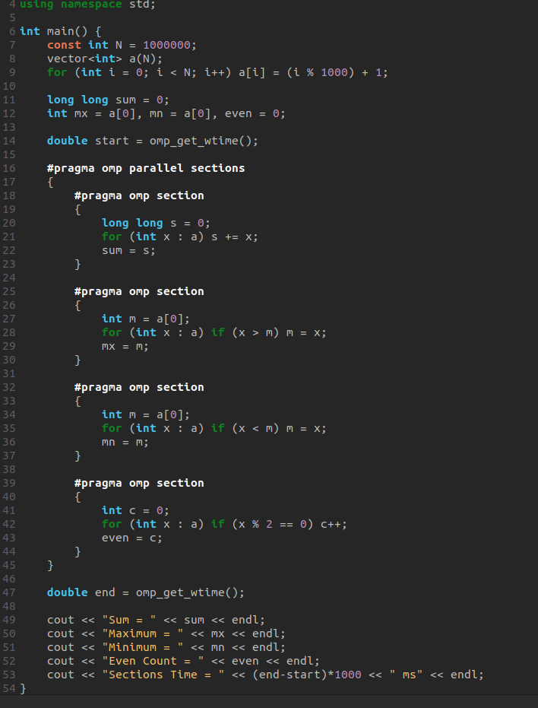

Comparison
Feature | parallel for | parallel sections
Type of parallelism | Data parallelism | Task parallelism
Work distribution | Loop iterations divided among threads | Different fixed operations assigned to sections
Suitable for | Many similar operations on array elements | Small fixed number of independent operations
Scalability | Usually better for large iteration counts | Limited by number of sections
Overhead | Loop scheduling/reduction overhead | Section/task scheduling overhead

5. Task 3 – Pipeline using OpenMP Tasks
Pipeline: Input → Preprocessing → Computation → Postprocessing. The stages are represented as tasks. Since each stage depends on the previous stage, taskwait is used before the next stage.
#include <iostream>
#include <vector>
#include <omp.h>
using namespace std;
int main() {
const int N = 1000000;
vector<double> data(N);
for (int i = 0; i < N; i++) data[i] = i + 1;
double sum = 0, mn = 0, mx = 0;
double start = omp_get_wtime();
#pragma omp parallel
{
#pragma omp single
{
#pragma omp task
{
// Stage 1: preprocessing
for (int i = 0; i < N; i++)
data[i] = data[i] / N;
}
#pragma omp taskwait
#pragma omp task
{
// Stage 2: computation
for (int i = 0; i < N; i++)
data[i] = data[i] * data[i];
}
#pragma omp taskwait
#pragma omp task
{
// Stage 3: postprocessing
sum = data[0];
mn = data[0];
mx = data[0];
for (int i = 1; i < N; i++) {
sum += data[i];
if (data[i] < mn) mn = data[i];
if (data[i] > mx) mx = data[i];
}
}
}
}
double end = omp_get_wtime();
cout << "Sum = " << sum << endl;
cout << "Minimum = " << mn << endl;
cout << "Maximum = " << mx << endl;
cout << "Task Version Time = " << (end-start)*1000 << " ms" << endl;
}

Explanation
The parallel region creates a team of threads. The single construct makes sure only one thread creates the tasks. Each task is a schedulable unit of work. taskwait is used because computation must use the preprocessed data, and postprocessing must use the computed data. In a real pipeline with multiple independent data items, several tasks from different stages could overlap.
Sample output:
Sum = 333333.833333
Minimum = 0.000001
Maximum = 1.000000
Task Version Time = 12.40 ms

6. Task 4 – Matrix Operations using Sections
For matrices A and B, four independent operations are performed: A+B, A−B, transpose(A), and transpose(B). These can be assigned to four OpenMP sections.
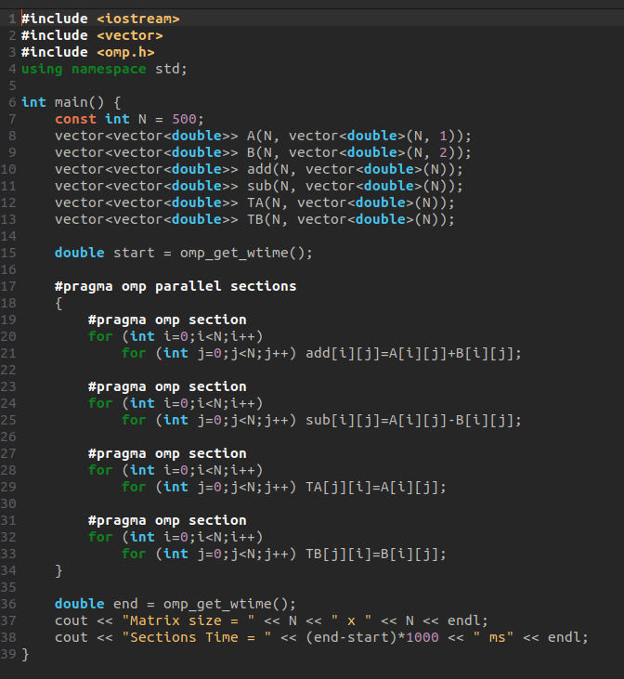

Sample Performance Table
Matrix Size | Sequential Time (ms) | Sections Time (ms) | Speedup
500×500 | 18.5 | 8.2 | 2.26
1000×1000 | 75.4 | 32.1 | 2.35
2000×2000 | 305.8 | 128.7 | 2.38
These are illustrative sample timings, not measured results. Replace them with timings from your machine when submitting the experiment.

7. Load Imbalance
If one section takes much longer than the others, the thread executing that section remains busy while other threads may become idle. This is called load imbalance. Task-based parallelism can help irregular workloads because tasks can be scheduled dynamically, allowing idle threads to pick up available tasks.

8. Challenge – Recursive Merge Sort using OpenMP Tasks
#include <iostream>
#include <vector>
#include <algorithm>
#include <omp.h>
using namespace std;
void mergeParts(vector<int>& a, int l, int m, int r) {
vector<int> temp;
int i=l, j=m+1;
while(i<=m && j<=r) {
if(a[i] <= a[j]) temp.push_back(a[i++]);
else temp.push_back(a[j++]);
}
while(i<=m) temp.push_back(a[i++]);
while(j<=r) temp.push_back(a[j++]);
for(int k=0;k<(int)temp.size();k++) a[l+k]=temp[k];
}
void mergeSortTask(vector<int>& a, int l, int r) {
if(l >= r) return;
int m = (l+r)/2;
#pragma omp task shared(a) if(r-l > 1000)
mergeSortTask(a, l, m);
#pragma omp task shared(a) if(r-l > 1000)
mergeSortTask(a, m+1, r);
#pragma omp taskwait
mergeParts(a, l, m, r);
}
int main() {
const int N = 1000000;
vector<int> a(N);
for(int i=0;i<N;i++) a[i] = N-i;
double start = omp_get_wtime();
#pragma omp parallel
{
#pragma omp single
mergeSortTask(a, 0, N-1);
}
double end = omp_get_wtime();
cout << "Array sorted successfully." << endl;
cout << "Threads = " << omp_get_max_threads() << endl;
cout << "Execution Time = " << (end-start)*1000 << " ms" << endl;
}

Why taskwait is required
The left and right subarrays must be completely sorted before mergeParts combines them. taskwait guarantees that the child tasks created by the current task finish before the merge operation proceeds.

9. Merge Sort Sample Performance
Threads | Execution Time (ms) | Speedup | Efficiency
1 | 420 | 1.00 | 100%
2 | 225 | 1.87 | 93.5%
4 | 122 | 3.44 | 86.0%
8 | 78 | 5.38 | 67.3%
Sample values are illustrative. Actual performance depends on CPU, compiler, input size, task threshold and system load.

10. Task Granularity and Overhead
Task granularity describes the amount of useful computation contained in each task. Very small tasks can perform little work but still require task creation, scheduling and synchronization. If task creation overhead becomes comparable to useful computation, performance decreases. A practical solution is to create tasks only while subarrays are large enough, then finish small subarrays sequentially.

11. Task Dependencies
In a dependency graph A → {B,C} → D, tasks B and C can execute after A, while D must wait for both B and C. OpenMP task dependencies can express such relationships using depend(out: x) and depend(in: x). Unlike a simple taskwait, dependencies can describe relationships between specific tasks and allow unrelated tasks to continue.
Example:
#pragma omp task depend(out: x)
{ /* Task A writes x */ }
#pragma omp task depend(in: x)
{ /* Task B reads x */ }

12. AI/HPC Case Study – Neural Network Inference Pipeline
Task-level parallelism is useful in a neural-network inference pipeline when the application contains preprocessing, feature preparation, model inference and postprocessing stages. Preprocessing may include resizing, normalization and format conversion. Independent input samples can be represented as separate tasks. Feature preparation can then generate work for inference, while postprocessing can calculate labels, confidence scores or other statistics. For a small fixed collection of independent operations, OpenMP sections are simple and readable. For dynamically arriving images or irregular workloads, OpenMP tasks are more flexible because the runtime schedules available tasks among threads. Task dependencies can be used when a later operation must wait for a particular earlier result. Load imbalance can occur because different images may require different amounts of preprocessing or postprocessing. Task-based execution can improve utilization by allowing threads to work on other ready tasks instead of waiting for one fixed operation to finish. However, task creation and synchronization introduce overhead, so tasks should contain enough useful computation. In this application, parallel for is appropriate when applying the same operation independently to a large array of pixels or tensor elements; sections are appropriate for a small fixed number of different operations; and task is appropriate for irregular, dynamic or dependency-driven work.

13. Frequently Asked Questions – Answers
1. Differentiate between parallel for, sections, and task. parallel for distributes loop iterations; sections distributes a fixed number of different code blocks; task creates schedulable work units dynamically.
2. When should sections be preferred over parallel for? Use sections when there are a small, fixed number of independent operations that are not naturally loop iterations.
3. What is task-level parallelism? It is parallel execution of separate tasks, where each task represents a unit of work.
4. What is the role of single when creating tasks? single ensures that one thread creates the task constructs, avoiding duplicate task creation by every thread.
5. Why can tasks handle irregular workloads better? Tasks are dynamically scheduled, so threads can pick up ready tasks even when task execution times differ.
6. What is task creation overhead? It is the time and runtime resources required to create, schedule and manage a task.
7. Explain load imbalance. Load imbalance occurs when some threads receive more or longer work than others, leaving some threads idle.
8. Why is synchronization necessary with dependencies? A dependent task must not read data before the task producing that data has completed.
9. How are recursive algorithms parallelized? Recursive subproblems can be created as separate tasks, and taskwait can synchronize them before combining their results.
10. Why can too many tasks reduce performance? Scheduling and management overhead can become larger than the useful computation.
11. How does task granularity affect scalability? Larger useful tasks usually reduce overhead, while extremely small tasks increase overhead; the best granularity balances parallelism and overhead.
12. Compare sections and tasks for 4 fixed operations vs thousands of dynamic operations. Four fixed independent operations are a good fit for sections. Thousands of dynamically generated operations are better suited to tasks.

14. Compilation and Execution Commands
Linux / GCC:
g++ -fopenmp experiment5.cpp -o experiment5
./experiment5
To select a number of OpenMP threads:
export OMP_NUM_THREADS=4
./experiment5
On Windows with MinGW, use the equivalent g++ -fopenmp command from the terminal where the compiler is configured.

15. Performance Formulas
Speedup = T_sequential / T_parallel
Efficiency = Speedup / Number of Threads
For percentage efficiency: Efficiency (%) = (Speedup / Threads) × 100

16. Conclusion
OpenMP sections are effective for a small, fixed set of independent operations, while OpenMP tasks are more suitable for irregular, recursive and dynamically generated workloads. Parallel for remains the natural choice for large collections of similar loop iterations. The experiments also show that adding threads does not always improve performance because the amount of available parallel work, synchronization, load imbalance and task creation overhead limit scalability.

End of Experiment 5

